### Laptop Request Catalog Item

**Team ID :** NM2025TMID17652

**Team Leader :** GAYATHRI.S

**Team member :** DIVYA SRI D

**Team member :** GAYATHRI K

**Team member :** GOPIKA J

**Team member :** GOPIKA R

Problem Statement:

Employees need a simple and quick way to ask for laptops at work. Right now, the process takes time, is done by hand, and often has mistakes because the form doesn’t adjust based on what the user selects.

To solve this, we will create a new form in ServiceNow that:

* Lets users request laptops using smart, easy-to-use fields.
* Checks that all the information is correct.
* Has a button to clear the form if needed.
* Saves all changes so they can be tracked and managed later.

**Objective :**

The goal of this project is to create a user-friendly laptop request form in ServiceNow that:

* Makes the request process faster and easier.
* Shows or hides fields based on user input.
* Includes clear instructions and checks for correct data.
* Tracks all changes for better management and future updates

**Skills *:***

• **ServiceNow Platform**

• **Catalog Item Creation**

• **Form Design**

• **Team Collaboration**

• **Basic Git**

### **ACTIVITY 1 :** UPDATE SET

### * Create Local Update set*

• **Open ServiceNow.**

• Click on **"All"** in the left menu and **search for "Update Sets."**

• Select **"Local Update Sets"** under **System Update Sets.**

• Click **"New"** to create a new update set.

• Fill in the **Name** as: **"Laptop Request."**

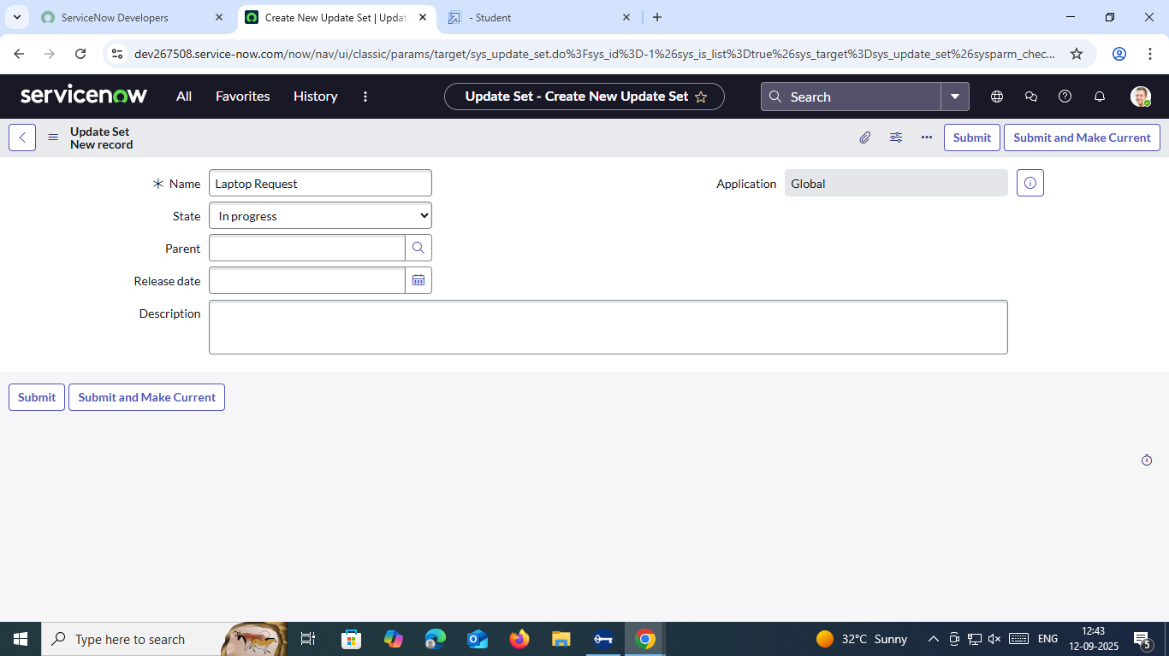

• Click **"Submit."**

• After that, click **"Make Current"** to activate the update set.

### **ACTIVITY 2:** Service Catalog Item

*Create Service Catalog Item*

1. **Open ServiceNow**
2. Click on **All** → then click **Service Catalog**
3. Under **Catalog Definitions**, select **Maintain Items**
4. Click the **New** button to create a new item
5. Fill in the details:
   * **Name**: Laptop Request
   * **Catalog**: Service Catalog
   * **Category**: Hardware
   * **Short Description**: Use this item to request a new laptop

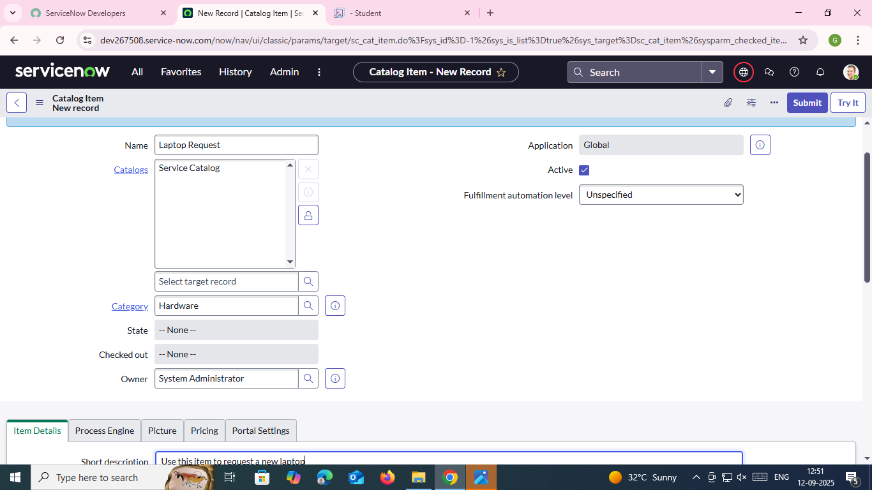

1. Click **Save**

*Add variables*

Step 1: Add Variables to the Catalog Item

1. After saving the catalog item, scroll down to the Related Lists section.
2. Click on Variables.
3. Click New and fill in the details for the first variable:
   * Question: Laptop Model
   * Type: Single Line Text
   * Name: laptop_model
   * Order: 100

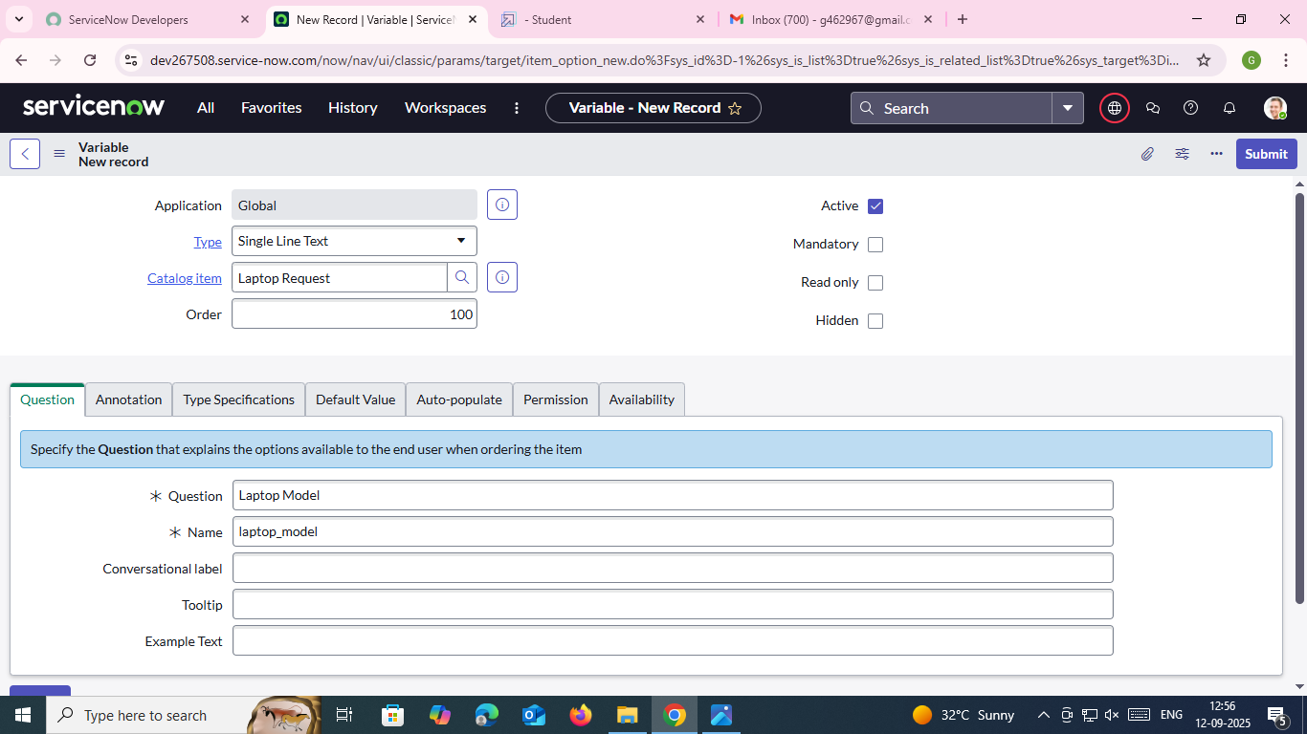

1. Click Submit.
2. Repeat the same process to add the remaining variables:
   * Variable 2
     + Question: Justification
     + Type: Multi Line Text
     + Name: justification
     + Order: 200
   * Variable 3
     + Question: Additional Accessories
     + Type: Checkbox
     + Name: additional_accessories
     + Order: 300
   * Variable 4
     + Question: Accessories Details
     + Type: Multi Line Text
     + Name: accessories_details
     + Order: 400

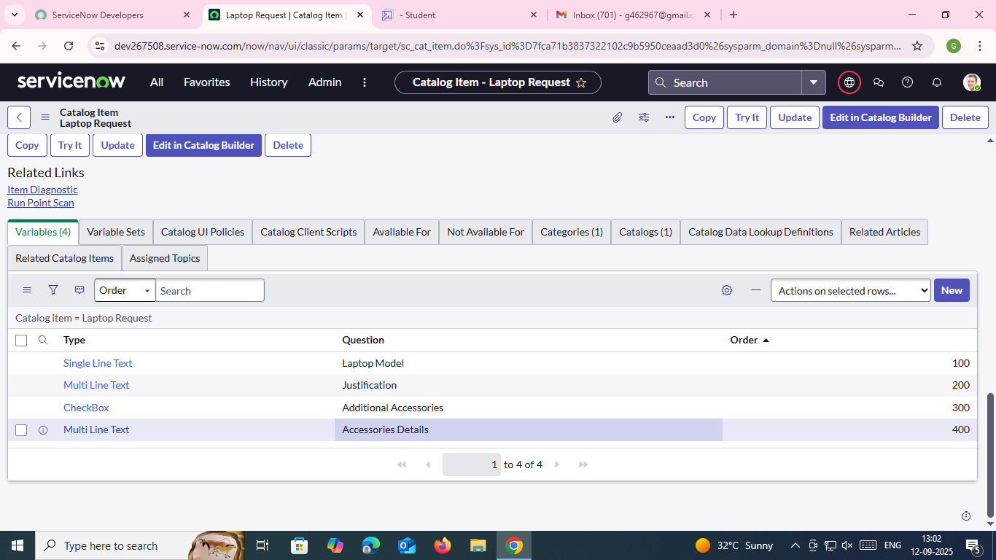

Step 2: Save the Catalog Item

* Once you’ve added all the variables, they will be linked to the catalog item you created earlier.
* Finally, click Save to update the catalog item with the new variables.

### **ACTIVITY 3:** UI Policy

### *Create Catalog Ui policies*

• Open the **Service Catalog** by clicking on **All**, then search for and select **Maintain Items**.

• Find the item called **Laptop Request** and open it.

• Scroll down and go to the **Catalog UI Policies** section.

• Click **New** to create a new UI Policy.

• Enter a short description: **Show accessories details**.

• Under **When to Apply**, set the condition:

* If **additional_accessories** is **true**.

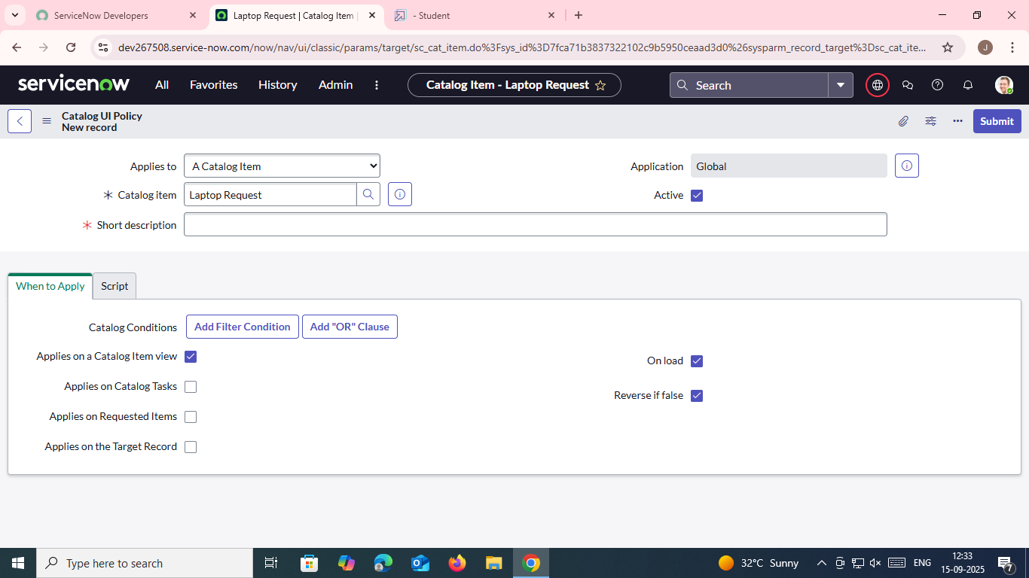

• Click **Save** (don’t click Submit yet).

• Scroll down to **Catalog UI Policy Actions**.

• Click **New** to add an action.

• Set:

* **Variable name**: accessories_details
* **Order**: 100
* **Mandatory**: True
* **Visible**: True

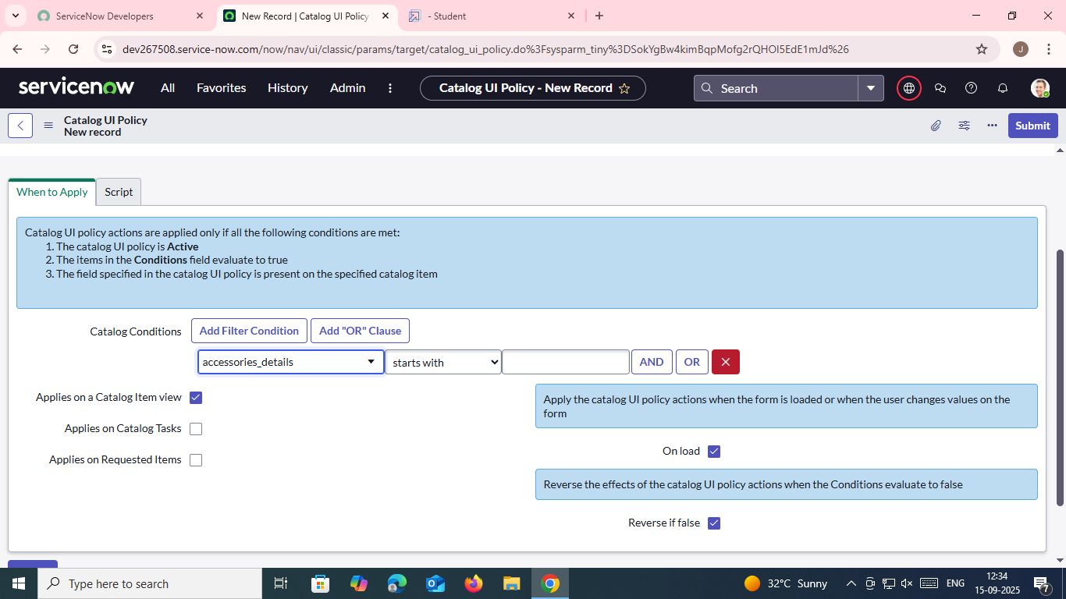

• Click **Save**.

• Finally, go back to the UI Policy form and click **Save** again.

### **Activity 4:** UI Action

### *Create ui action*

• Open ServiceNow.

• Click on All, then search for and select UI Actions under System Definition.

• Click New to create a new UI Action.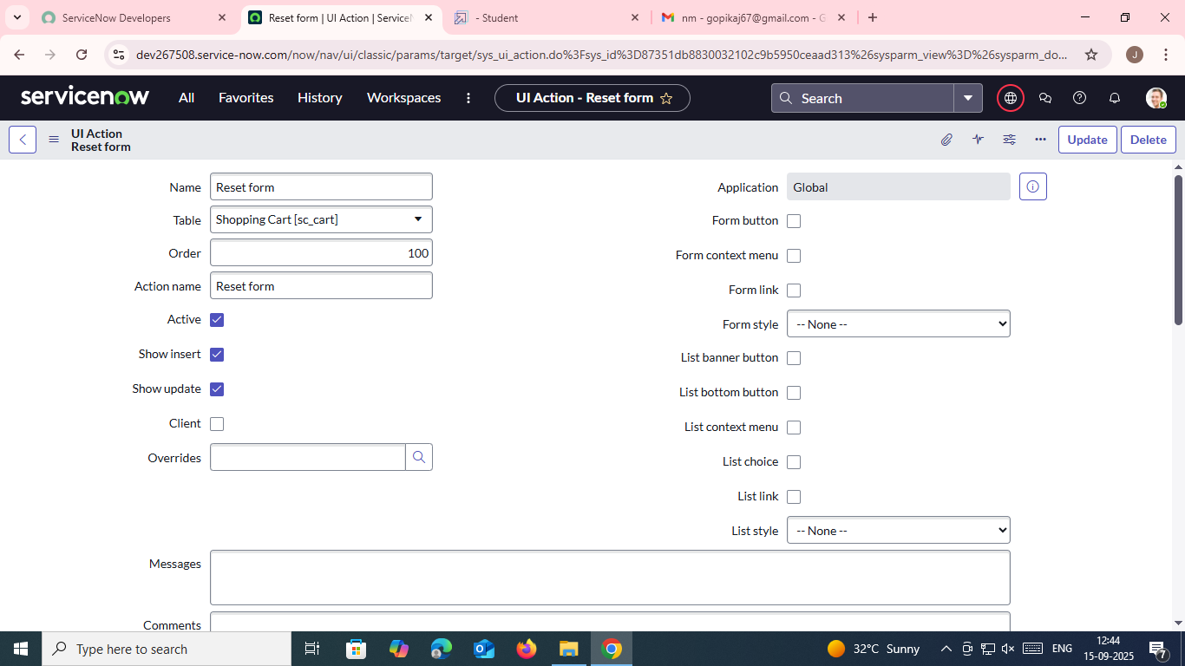

• Fill in these details:

* Table: Shopping Cart (sc_cart)
* Order: 100
* Action Name: Reset form
* Check the box for Client (this means it runs on the user's browser).

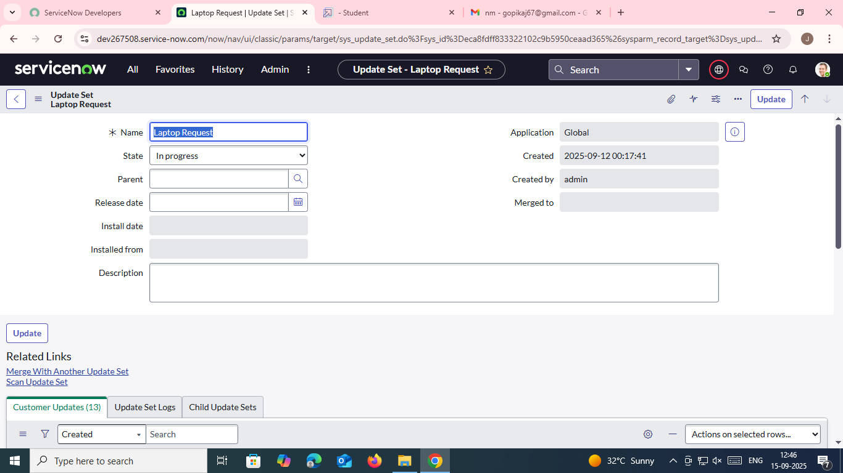

• In the Script box, enter the following:

function resetForm() {

g_form.clearForm(); // Clears all fields in the form

alert("The form has been reset.");

}

• Save the UI Action.

### **ACTIVITY 5 :** Export Update set

### *Exporting changes to another instances*

• In **ServiceNow**, click **All**, then search for and select **Local Update Sets**.

• Open the update set you created — for example: **"Laptop Request Project"**.

• Change the **State** to **Complete**.

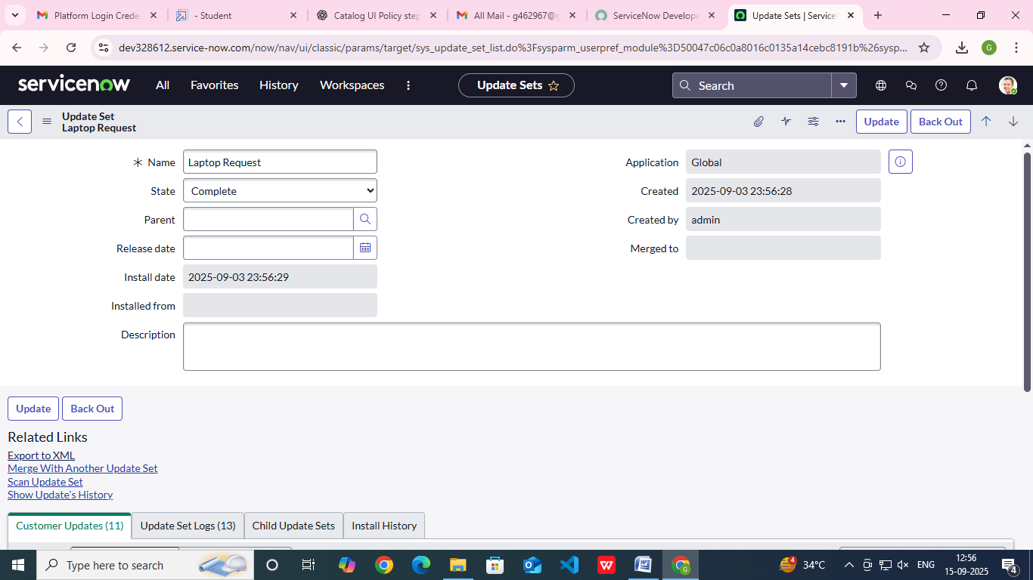

• Scroll down to the **Updates** tab — here you'll see all the changes made in this update set.

• Click **Export to XML** — this will download the update set as an XML file.

Activity 6 :Login to another Instance

### *\** Retrieving the update set*

• In **ServiceNow**, click **All**, then search for and select **Local Update Sets**.

• Open the update set you created — for example: **"Laptop Request Project"**.

• Change the **State** to **Complete**.

• Scroll down to the **Updates** tab — here you'll see all the changes made in this update set.

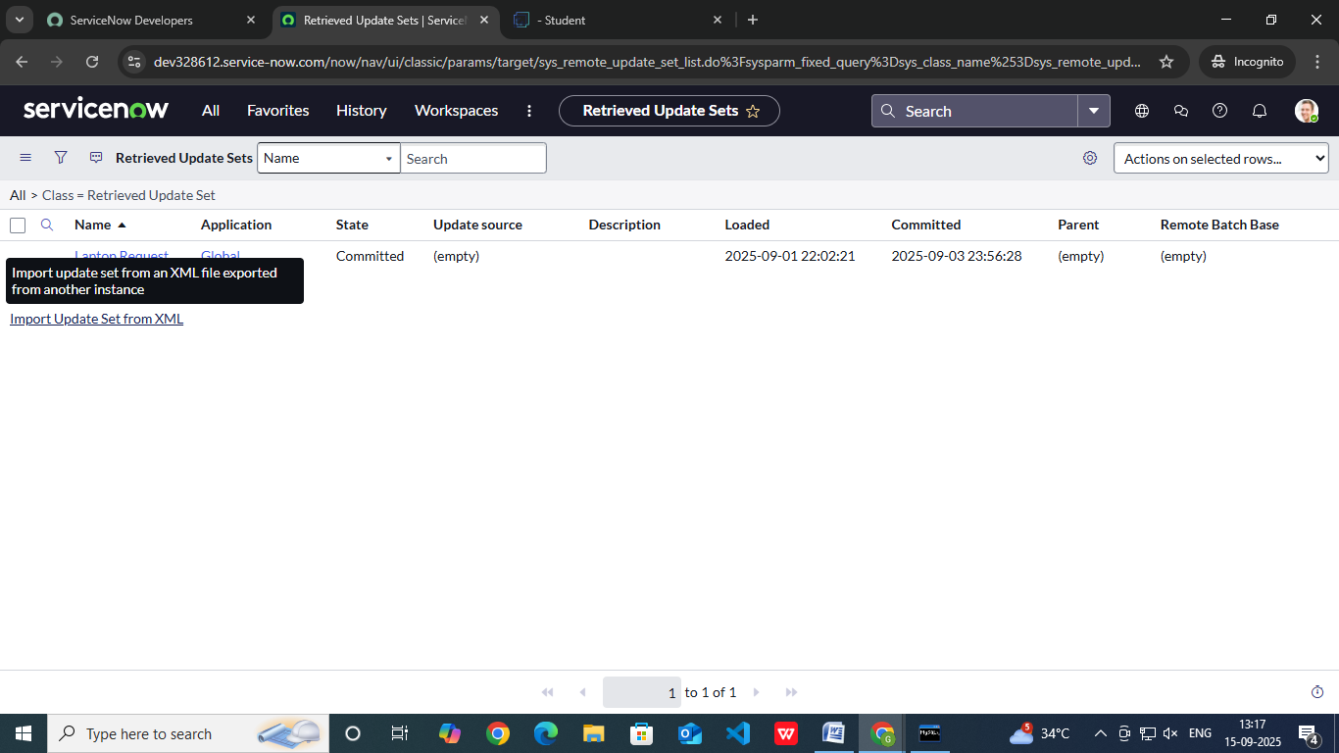

• Click **Export to XML** — this will download the update set as an XML file.

### Activity 7: Testing

### * Test Catalog Item*

• In the **target ServiceNow instance**, search for **Service Catalog**.

• Click on **Catalog** under the Service Catalog section.

• Open the **Hardware** category and search for **Laptop Request**.

• Open the **Laptop Request** item — at first, only **three fields** are visible.

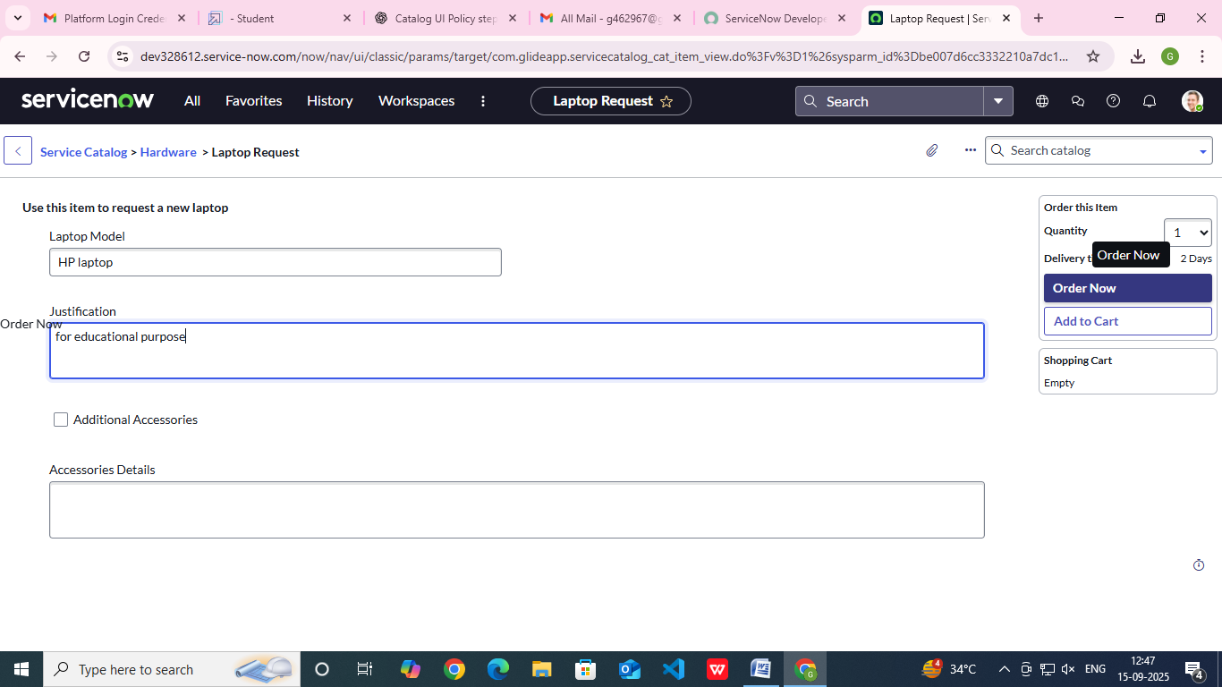

• When you check the **Additional Accessories** box:

* The **Accessories Details** field appears.
* It becomes **mandatory** to fill in.

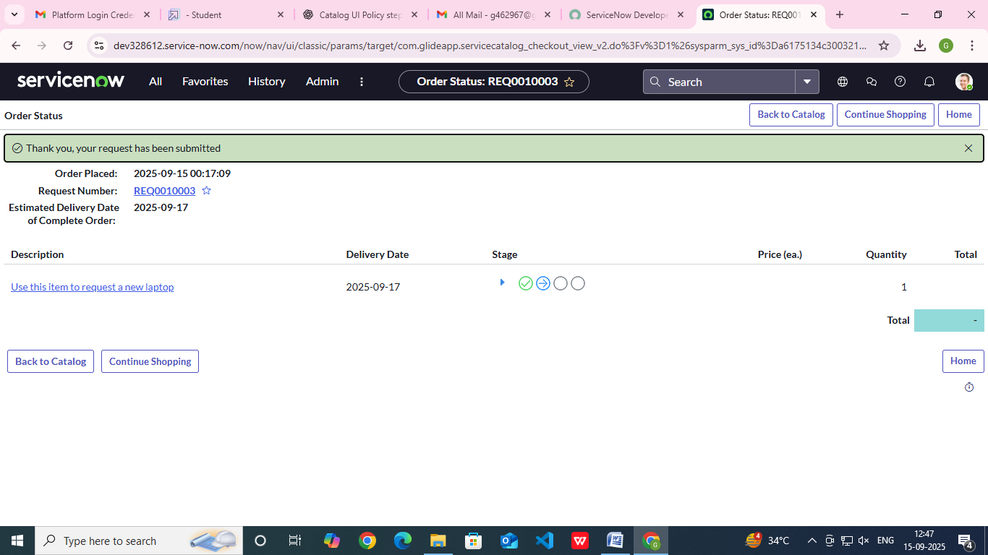

CONCLUSION :

The Laptop Request Catalog Item project makes requesting laptops easier inside the company by using ServiceNow’s Service Catalog. It creates a form that changes based on what the user wants — for example, additional accessories only show up when needed. This helps reduce mistakes, speeds up the process, and gives people a better, more modern experience.